NG18 Khwai Private Reserve
2025 Monitoring Report


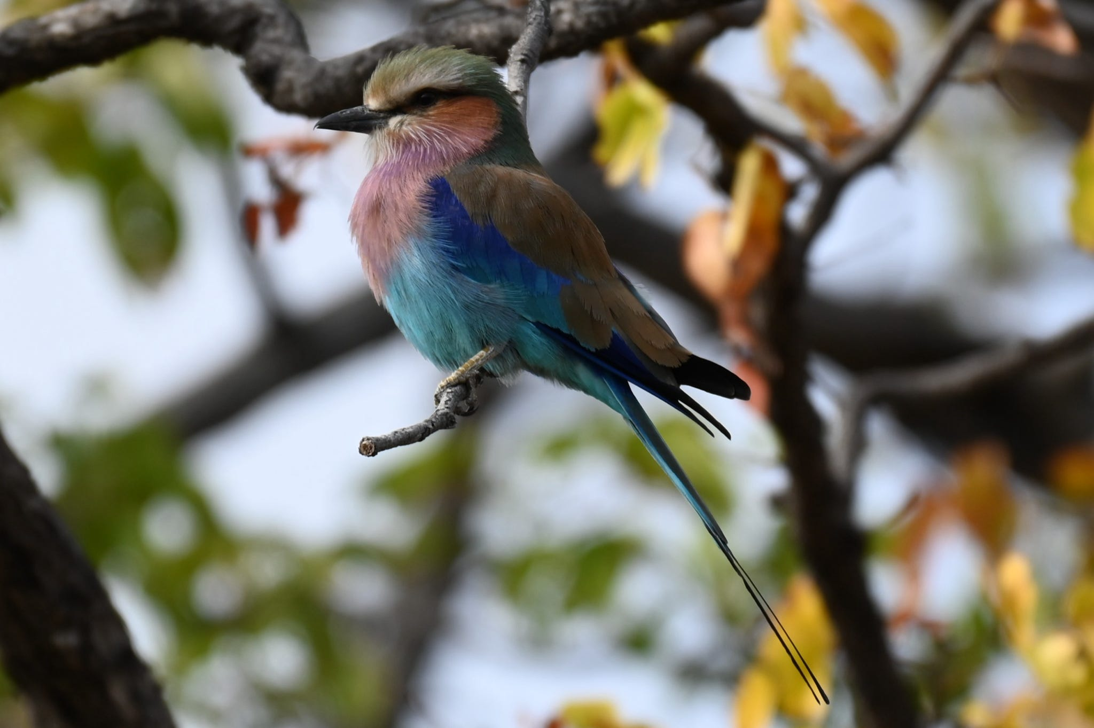



Lilac breasted roller in Khwai Private Reserve, 2025. Credit: Dave White
Contents
Summary 3
Introduction 4
Methods 6
Rainfall, flow, and flooding 6
Broad-based bird surveys 6
Waterbird surveys 6
Herbivore surveys 7
Aquatic macroinvertebrate sampling 7
Water quality sampling (Mike to fill in) 7
Camera traps 7
Analysis 8
Results and discussion 9
Rainfall, flow, and flooding 9
Broad-based bird surveys 13
Waterbird surveys 13
Herbivore surveys 16
Freshwater invertebrate sampling 23
Water quality sampling 23
Camera traps 23
Bibliography 24
Appendix 26

Summary
In July 2025, the PLuS alliance surveyed birds, mammals, and aquatic macroinvertebrates in NG18 Khwai private reserve for the third time, replicating survey methods and locations established in 2023. For context, we also compared 2025 flooding, flow and rainfall in NG18 and the whole Okavango Delta with previous annual data. Rainfall in the Delta was higher in 2025 than in 2023 and 2024, but still lower than the long-term average. This is the third year in a row that rainfall has been below this long-term average. However, flooded area was the largest since 2021 and higher than the long-term average, reflecting higher flows observed upstream of the Delta at river gauges in Mohembo and Rundu. Accordingly, water levels were high in NG18, providing for a more productive freshwater ecosystem. This was reflected in higher abundance and richness of bird and vertebrate species. In our replicates of the bird point surveys, we observed higher species richness and abundance at each site and overall than in 2023 or 2024. We observed an increase in insect-eating birds, highlighting the higher number of invertebrates, potentially because of higher water levels. Incidental observations of other vertebrates during bird surveys were less than in previous years at all sites, possibly reflecting the poor conditions of the previous two years. We conducted vehicle-based herbivore surveys along transects through two predominant broad habitat types in NG18, mopane woodland and floodplain. We detected five species that we had not observed before 2025, and 17 species overall, more than in both 2023 and 2024. Abundance was higher in the mopane, but richness was higher in the floodplain. We observed higher overall abundance compared to previous years. We estimated density of herbivores using distance sampling. Herbivore populations fluctuated depending on species, with elephants, buffalo, and impala increasing since 2023, and zebra, giraffe, and kudu declining. Declining populations of these vertebrates may be indicative of the dry conditions of the previous two years, and as zebra and kudu were resident, this is unlikely due to detection differences resulting from movement at larger scales, but this cannot be discounted. It is expected that localised populations will recover following the more extensive flooding in 2025. We set up temporary camera traps over a few nights in key locations, and detected four mammal species, including lion and leopard, using bridges. Overall, increased flooding in 2025 in NG18, compared to 2023 and 2024, probably contributed to increased vertebrate populations.

Introduction
The Okavango Delta is an internationally significant wetland in north-west Botswana. The Delta is a 40,000km² mosaic of permanent rivers, semi-permanent rivers, seasonally flooded grasslands, dry grasslands, riverine woodlands, and dry woodlands (McCarthy et al., 2012; Moliner Cachazo et al., 2023). An average of 6635km² is inundated annually (3487km²-10,109km²; Inman and Lyons, 2020). Although rainfall in the Okavango delta is low (448mm/year in Maun, 532mm/year in Shakawe; McCarthy, 2000), annual flooding is driven by high amounts of rainfall, upstream in the Angolan highlands (1300mm/year; Lourenco et al., 2023). Water travels to the Delta along the Cuito and Cubango Rivers, which flow through Angola and Namibia, merging into the Okavango River in southern Angola, before flowing into Botswana, where the water spreads out into an alluvial fan because of the extremely small gradient (Gumbricht et al., 2001; Milzow et al., 2009).
The Okavango Delta’s heterogenous mosaic of dryland and wetland environments supports 444 bird species, 122 mammal species, 97 reptile and amphibian species, and 1300 plant species (Ramberg et al., 2006). This includes at least 16 waterbird species which rely on the wetlands for breeding, four of which are threatened globally (Francis et al., 2021). Further, the Delta supports populations of many threatened mammal species, including cheetah (Acinonyx jubatus), African wild dog (Lycaon pictus), and hippopotamus (Hippopotamus amphibius), African bush elephant (Loxodonta africana), lion (Panthera leo) and leopard (Panthera pardus). Accordingly, the Okavango Delta is listed both as a Ramsar wetland of international significance (Ramsar, 2021), and a UNESCO World Heritage Site (UNESCO, 2024).
The Khwai Private Reserve (KPR; NG18 concession) is a large (~2,000km²) wildlife management area, west of Khwai village in the Okavango Delta. It is north of Moremi Game Reserve and west of Chobe National Park. KPR supports large concentrations of wildlife, including many threatened species such as African bush elephant, African wild dog, lion, leopard, cheetah, and hippopotamus. Herbivores such as impala (Aepyceros melampus), waterbuck (Kobus ellipsiprymnus), zebra (Equus quagga), reedbuck (Redunca fulvorufula), tsessebe (Damaliscus lunatus), hippopotamus, and Cape buffalo (Syncerus caffer) support an intact large carnivore guild (Burger, 2020), comprising African wild dog, lion, leopard, cheetah, spotted hyaena (Crocuta crocuta), and occasional brown hyaena (Hyaena brunnea). Like the larger Delta, the KPR contains a variety of ecosystem types, including floodplain grasslands, permanent rivers, permanent swamps, riverine and floodplain forests. There are also large areas of terrestrial ecosystems, including mopane (Colophospermum mopane) and other woodlands, and savanna and scrub. Human impact is minimal, but tourist camps have been established to allow for photographic safaris within the reserve, leading to the establishment and maintenance of additional infrastructure including pumped pans and a network of single unsealed vehicle tracks.
To track changes in ecosystem health over time, repeatable and standardised surveys are needed, focusing on regularly ‘sampled areas’. Fauna presence and abundance vary according to changes in resource availability over seasonal, annual, and spatial scales. The dynamic wetland ecosystem within KPR presents challenges with replication, as variable flooding extent may limit access to survey locations, and consultation with experienced guides is vital in the monitoring of these ecosystems. Starting in 2023 as part of the university course “River Basin Ecosystem Management”, students and staff from the University of New South Wales (Australia), Arizona State University (United States), Kings College London (United Kingdom) and the University of Botswana have conducted annual biodiversity surveys in the KPR with the support of Natural Selection. Long term survey sites were established in 2023 with input from land managers, local rangers, and guides, and have been surveyed in 2024 and 2025. This report describes the 2025 survey methodology, comparing results to the 2023 and 2024 surveys, elucidating a trend over time.
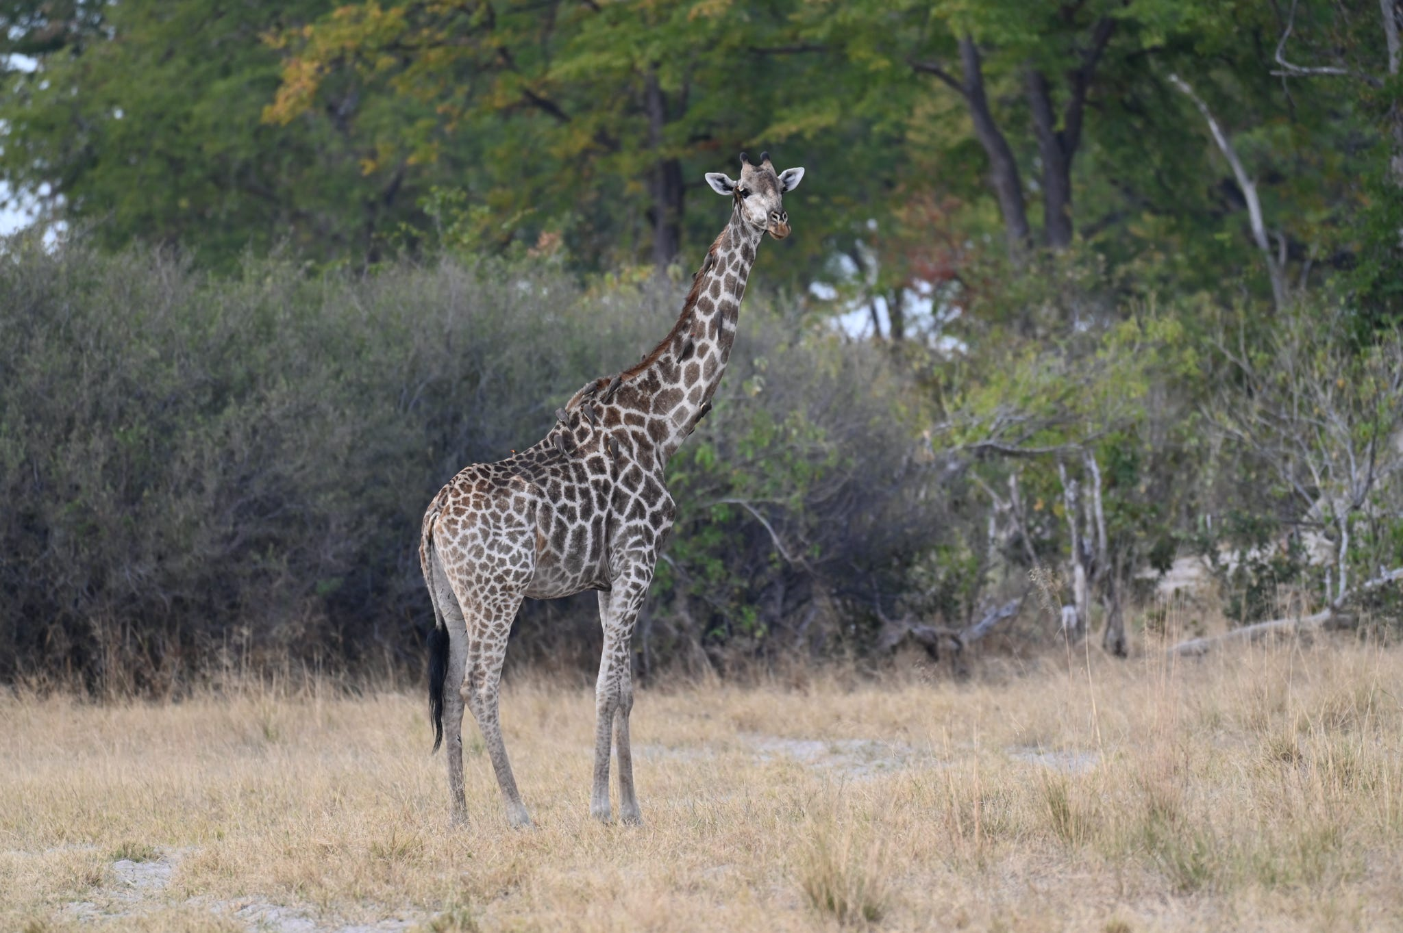
Giraffe in Khwai Private Reserve, 2025. Credit: Dave White

Methods

Rainfall, flow, and flooding
We obtained rainfall, flooding, and flow data for the Okavango Delta and for KPR. Annual cumulative precipitation for the Okavango Delta was determined using the Climate Hazards Group InfraRed Precipitation with Station data (CHIRPS) (Muthoni et al. 2019, Shen et al. 2020), which combines satellite imagery and ground station data to create a rainfall time series with a resolution of 0.05° from 1980-2025. We obtained water level data for the Okavango River at Mohembo and Rundu to track recent (2018-2025), monthly and annual flow pulses to the Okavango Delta. We also estimated maximum annual (1988-2025) inundation extent (July-September), when flooding was most widespread, across the Okavango Delta study area using Landsat 5,7 and 8 rasters, based on a short-wave infrared threshold (Inman and Lyons, 2020).

Broad-based bird surveys
eBird is a global citizen science project that collects data on bird communities, comprising one of the largest biodiversity projects in the world. We recorded eBird observations (Sullivan et al., 2014) while at KPR, both at camp and during surveys. Each day, one individual recorded the identities and count of each species observed. The location and time of each observation was also recorded. The final eBird list documented the diversity and abundance of all bird species observed on KPR, during the trip, including birds detected during formal surveys (see below) and at other times while present in KPR.

Waterbird surveys
We conducted waterbird surveys on three days (01, 02, 04 JUL 2025) between 11:00 and 15:00, from the same three points surveyed in 2023 and 2024 on the floodplain (Fig. 1). Observers identified bird, mammal, and reptile species and recorded their abundance, with care taken not to double count individual species that moved between survey points. For analysis, we separated waterbirds into five functional groups: carnivores, herbivores, insectivores, omnivores, and piscivores (Table A1). We calculated overall species richness (across all sites and all surveys), total species richness at each site, mean daily species richness at each site and overall, mean daily species abundance at each site and overall, and overall species abundance (across all sites and surveys). We also calculated overall median daily species richness and abundance, and maximum species richness and abundance for functional groups.
We classified mammal and reptile species into similar functional groups: carnivores, herbivores, and omnivores (Table A2), and calculated maximum daily species richness and abundance per site, and median overall daily species richness and abundance.

Herbivore surveys
We conducted vehicle based terrestrial herbivore surveys over three days (01, 02, 04 JUL 2025). We surveyed daily between 0800-1330 with two expert observers and between four and six student observers, with one person designated as a scribe on each survey. A vehicle was driven at a speed of 5-10km/hr, along our previously predetermined 19.5km circuit, split into two transects characterised by habitat type: ‘mopane’ woodland (12.2km) and generally dry ‘floodplain’ (7.3km) (Fig. 1). Observers were stationed on each side of the vehicle, facing opposite directions and continuously scanning for mammal species on either side of the vehicle, assisted by the vehicle’s driver/guide. When an animal was spotted (all large mammals and some small mammals), the vehicle was stopped, and data were collected by the whole team. We collected species, count, distance from the vehicle (using a Nikon laser range finder), bearing from the vehicle, and demographic information of each individual (sex, broad age categories [adult, subadult, juvenile]) where possible. The GPS coordinates of each detection were also recorded, along with the odometer reader (the distance along the transect). This information was relayed to the scribe, who recorded it on a datasheet.

We calculated overall species richness and abundance for the predominant habitat types on each of the two transects (hereafter ‘mopane’ and ‘floodplain’, Fig. 1) and compared species richness and abundance for different orders (Artiodactyla, Carnivora, Perissodactyla, Primates, Proboscidea, Rodentia, Struthioniformes). The 2025 results were compared with previous years. We also used the ‘Distance’ package (Marshall et al., 2024) to estimate a single Detection Function for each species in each habitat and calculated the density of each species in each habitat. Overall densities (both habitats combined) were used to estimate the abundance of each species across the entire KPR (~2000km²).

Aquatic macroinvertebrate sampling
Xx

Water quality sampling (Mike to fill in)

Camera traps
Two Bushnell camera traps were placed at three sites and collected still images to capture animal use of bridges over three days and nights. Cameras were collected at the end of the trip, and all captured images were manually reviewed for species detections.

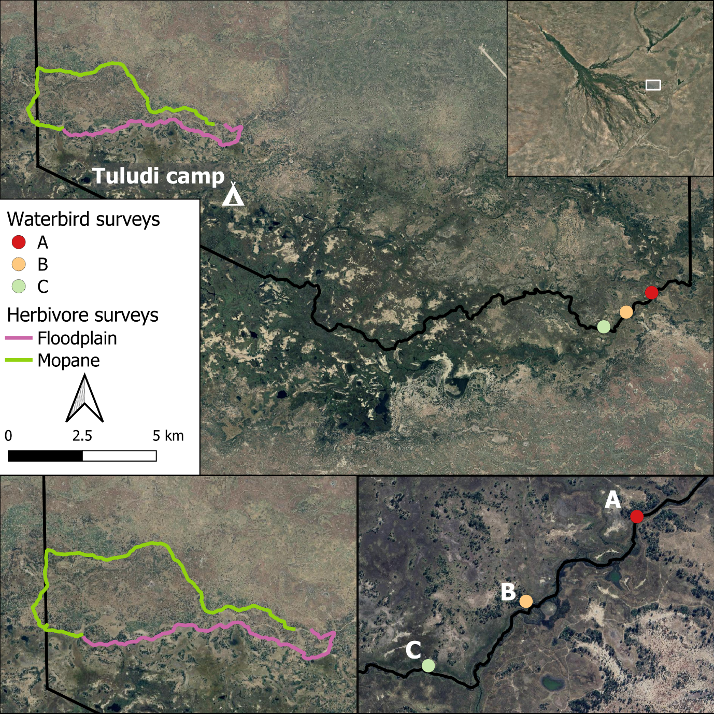
Figure 1. Location of survey areas on NG18 Khwai Reserve and Tuludi Camp, in relation to the floodplain in the Okavango Delta (inset, top right), showing the route for herbivore surveys (in mopane and floodplain habitats) and waterbird survey points (A-C).

Analysis
Data were collated and analysed in R (R Core Team, 2024), and maps were made using QGIS (QGIS.org, 2024).

Results and discussion

Rainfall, flow, and flooding

Rainfall in the Okavango Delta
Cumulative annual rainfall in the Delta was almost 400mm to September 2025, suggesting that it will exceed the long-term average annual rainfall. Rainfall was higher than in 2023 and 2024 (Fig. 2). This was reflected in the wet conditions in the KPR during wildlife surveys.

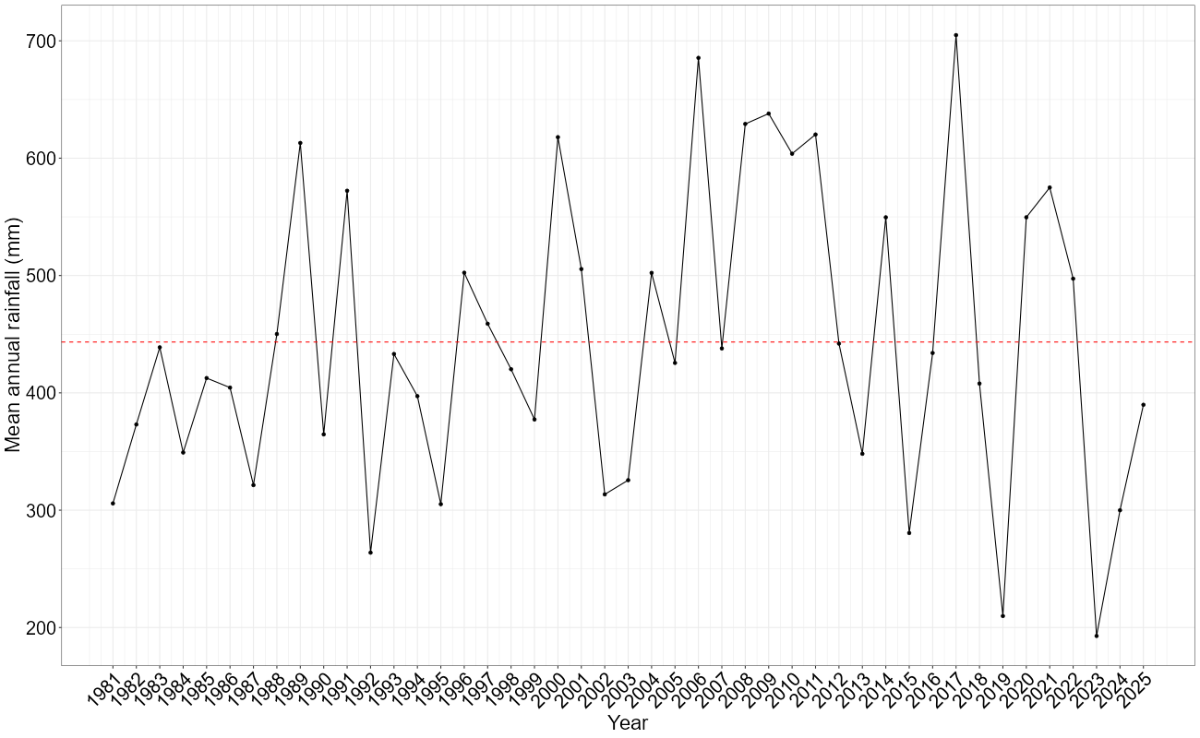
Figure 2. Annual cumulative precipitation over the entire Okavango Delta (inset polygon), using the Climate Hazards Group InfraRed Precipitation with Station Data (CHIRPS) (Muthoni et al., 2019; Shen et al., 2020), showing the long-term average (dashed red line).

Flow in the Okavango River
The flow in the Okavango River at Rundu was the highest recorded since 2019/20 (Fig. 3), reflecting higher rainfall in the Angolan Highlands.

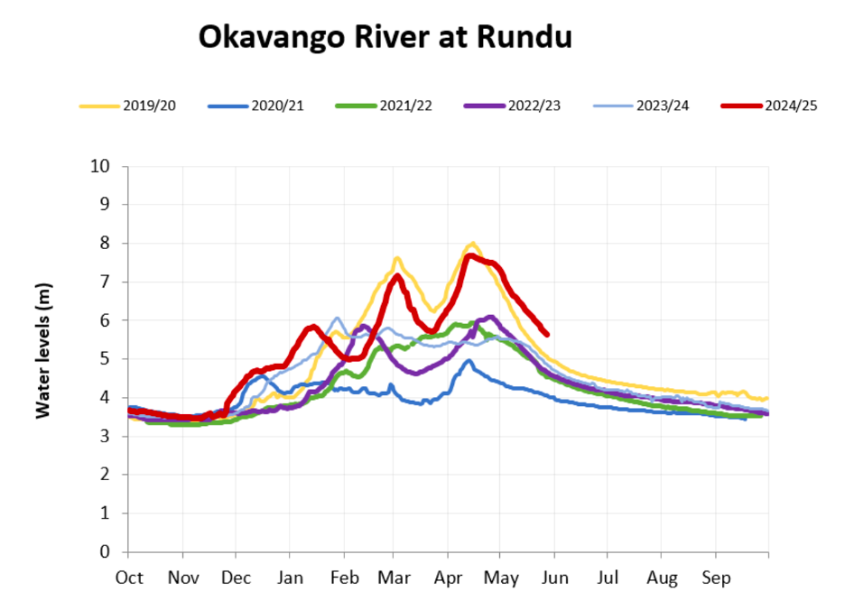
Figure 3. Okavango Water level at Rundu

Flooding in the Okavango Delta
Flooded area in 2025 (6819km2, Fig. 4) was the highest since 2020 and was higher than the long-term median of 6250km2. Visual comparison of the flood extents of the 2025 flood and the large flood in 2011 in the whole delta (Fig. 5) and NG18 (Figs. 6 and 7) highlights that the 2011 flood was more widespread but also patchier, with the water in the 2025 flood more concentrated around core rivers.
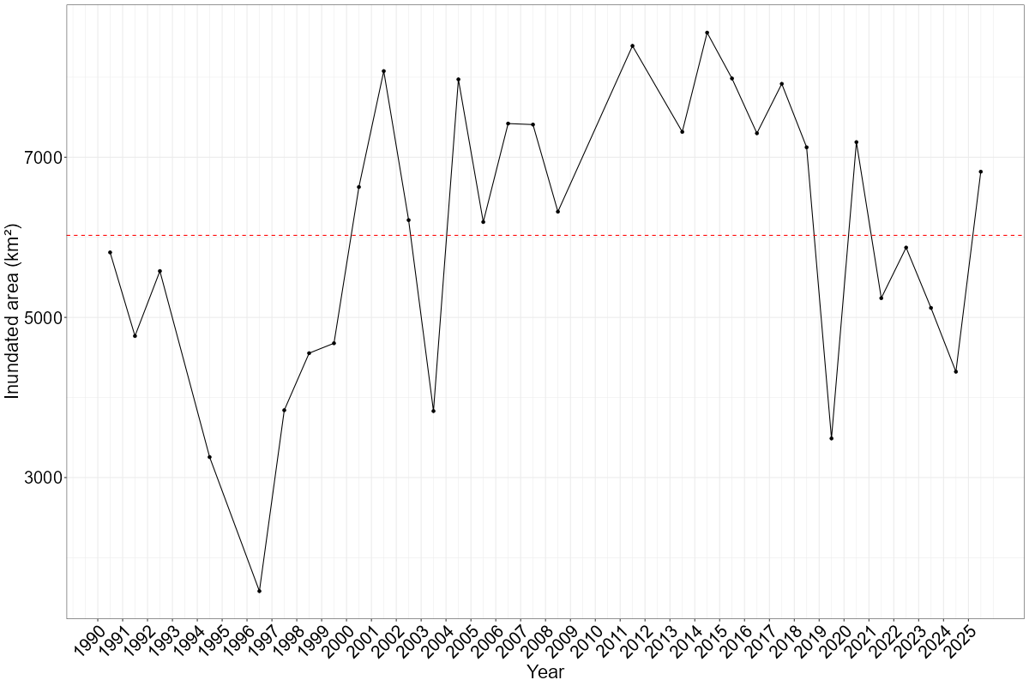
Figure 4. Flooded area (km2) over the Okavango Delta, 1988-2025, based on maximum median area flooded using Landsat imagery (Inman and Lyons 2020), showing the long average median (red dashed line).
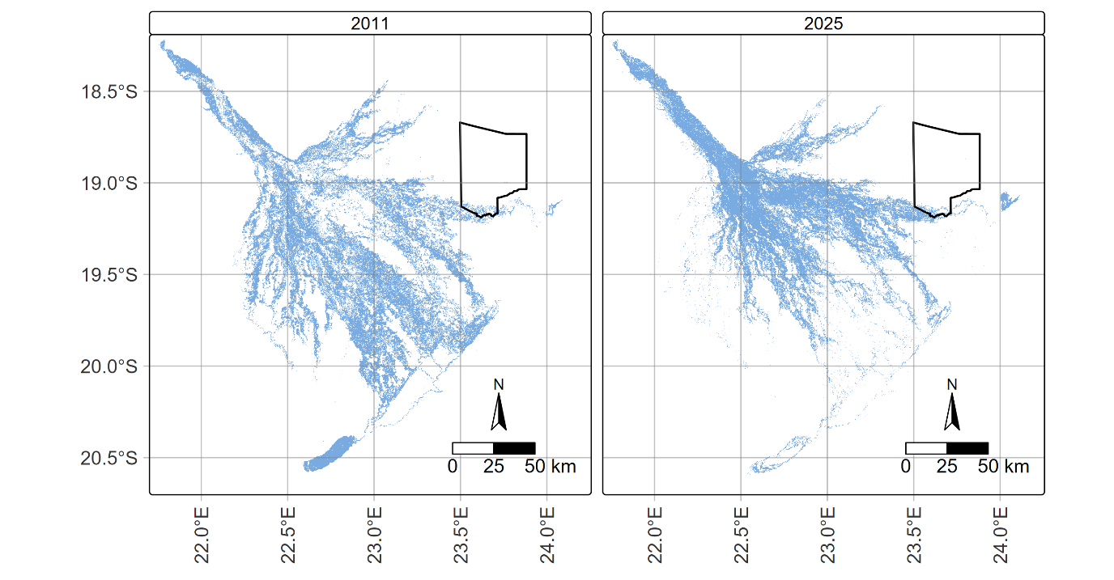
Figure 5. Flooding extent in 2025 (right) compared to maximum flooding extent in 2011 (left) of the Okavango Delta, relative to NG18 (black outline) based on methods developed by Inman and Lyons (2020).
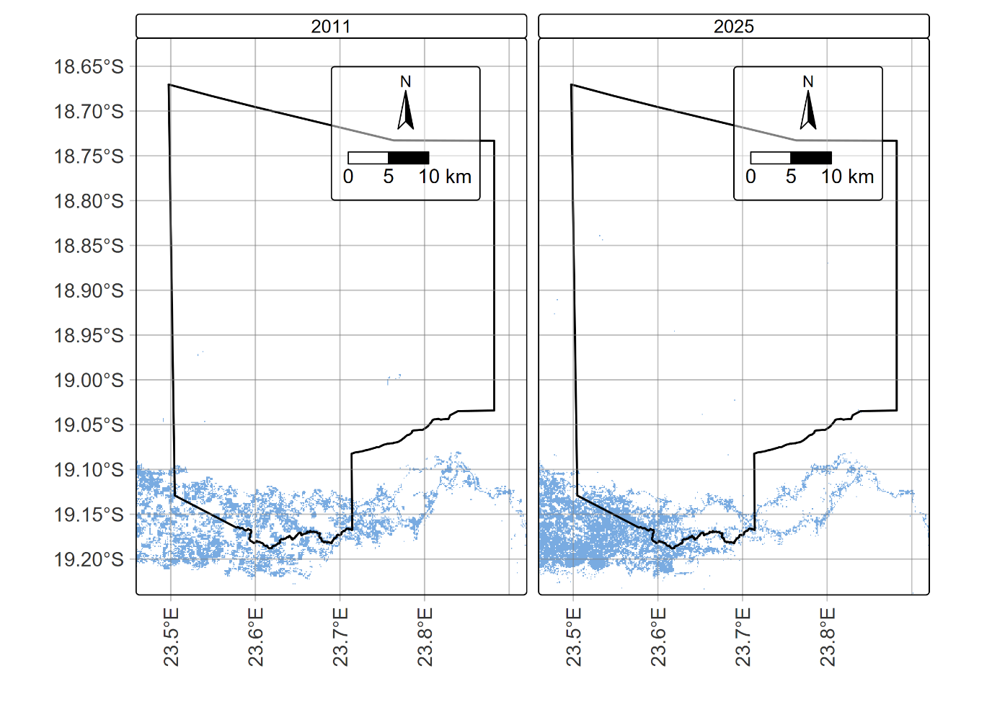
Figure 6. Flooding extent in 2025 (right) compared to maximum flooding extent in 2011 (left) in NG18 (black outline) based on methods developed by (Inman and Lyons, 2020).
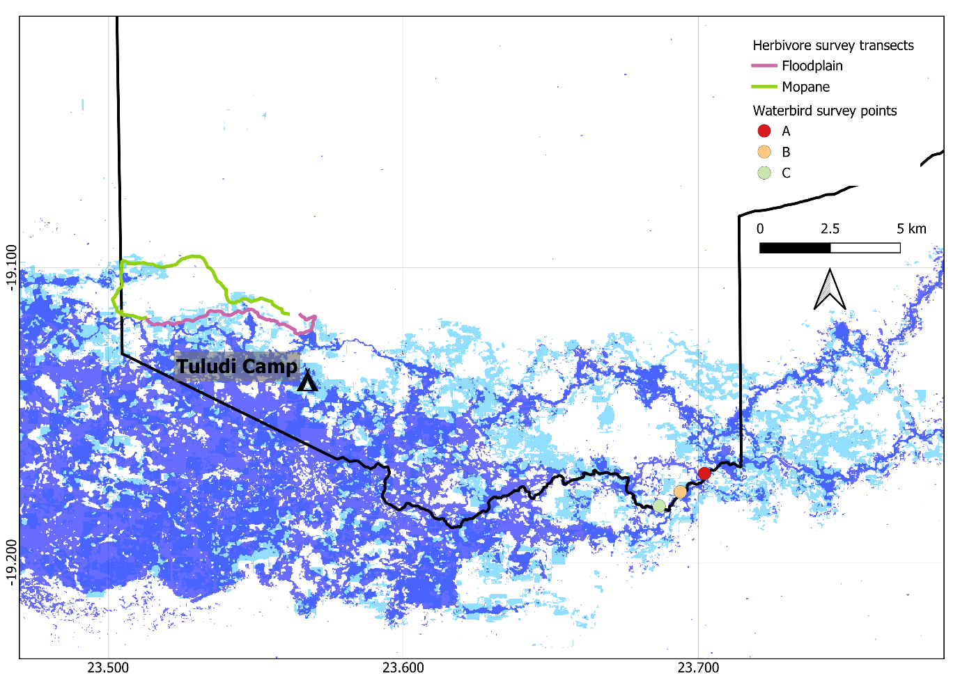
Figure 7. Overlay of 2025 flooding (dark blue) on maximum flooding (3-month median) and the maximum 3-month median in a very high flooding extent in 2011 (light blue), with data derived from Landsat imagery (Inman and Lyons 2020) for NG18 Khwai Reserve

Broad-based bird surveys
We observed 55 bird species in 2025 (1st – 5th July) (Table A3), recorded on eBird.

Waterbird surveys
We observed 72 bird species during our waterbird surveys, including 18 carnivore, six herbivore, 22 insectivore, 20 omnivore, and five piscivore species (Table A1). Total species richness was 49 at site A, 45 at site B, 30 at site C, and 72 for all sites (Fig 8). Mean daily species richness was highest at site B (24 species), then site A (23 species), with lowest richness at site C (17 species). Overall mean species richness was 41 species (Fig 8). Mean daily abundance was highest at site A (71 individuals), then site B (60 individuals), then site C (37 individuals). Total species richness was higher across all sites in 2025 compared to 2023 and 2024, as was mean daily species richness (Fig 8). Total abundance and mean daily abundance were higher in 2025 compared to 2023 and 2024 across all sites and overall.
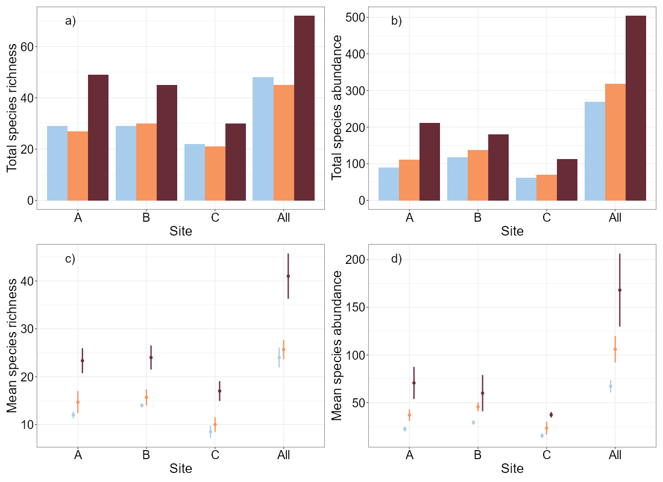
Figure 8. Waterbird survey results for 2023 (blue), 2024 (orange), and 2025 (purple) at each site and across all sites, including total species richness (a) and abundance (b), mean daily species richness (c) and abundance (d)
We separated waterbirds into functional groups (Table A1). Carnivorous species had the highest median species abundance and richness, probably reflecting high productivity in the surrounding wetland. Herbivore abundance and piscivore richness were lowest. Species richness was higher than or equal to previous years in all functional groups, except for piscivores, which were higher in 2023. Species abundance was lower for carnivores, despite their high richness, and higher for all other functional groups (Figs. 9 and 10). Insectivores had much higher species richness and abundance in 2025 than in previous years, suggesting larger amounts of insects because of the higher water levels (Fig. 4).
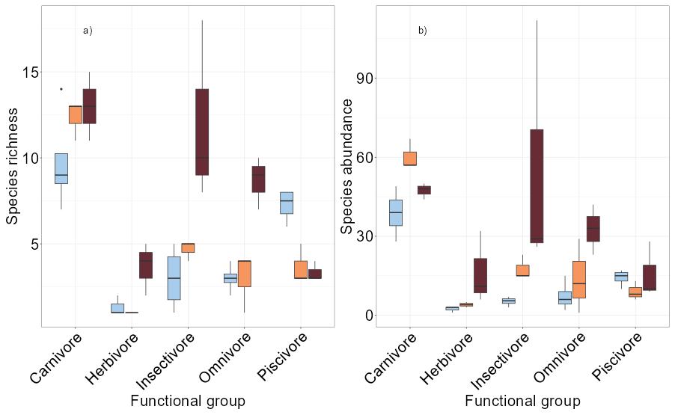
Figure 9. Box plots of daily species richness and abundance (n = 4 days) of birds across all waterbird survey sites for each functional group, in 2023 (blue), 2024 (orange), and 2025 (purple)
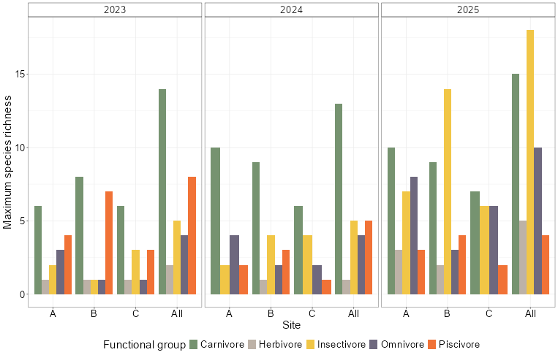
Figure 10. Maximum daily species richness of birds in 2023, 2024 and 2025 at each site, across the four days, for each functional group during waterbird surveys, including across all sites.
During waterbird surveys, we identified and counted all other vertebrate species (mammals and reptiles) either on the river or in riparian areas. Herbivores had the highest species richness and abundance (mostly impala and red lechwe). We did not observe any omnivorous species in 2025, and while species richness was the same as 2024, species abundance was lower than both 2023 and 2024 (Figs. 11 and 12).

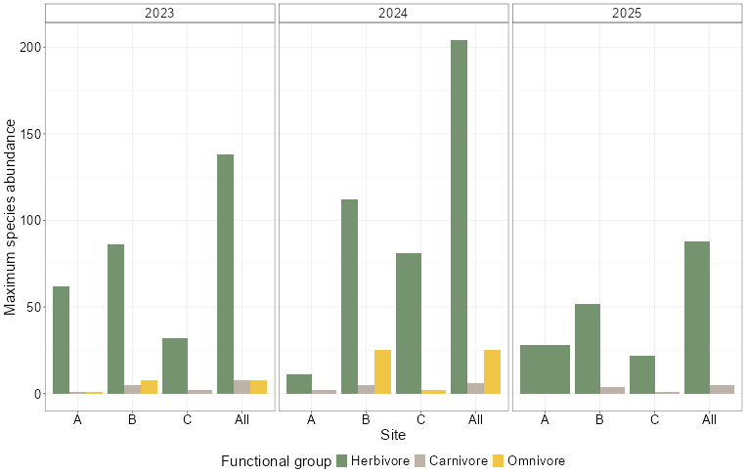
Figure 11. Maximum abundance of surveyed mammals and reptiles at each waterbird survey site in each functional group, including across all sites, for 2023, 2024, and 2025

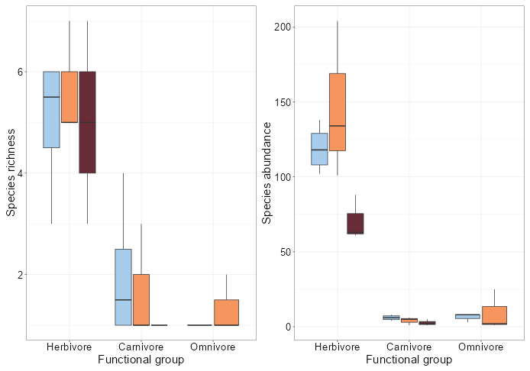
Figure 12. Box plots of daily species richness and abundance (n = 4) of incidentally observed mammal and reptiles across all waterbird survey sites for each functional group in 2023 (blue), 2024 (orange), and 2025 (purple).

Herbivore surveys
We detected 17 species across six surveys of two transects (three ‘mopane’ replicates, three ‘floodplain’ replicates) in 2025, more than in 2023 (16, Fig. 13) and 2024 (13, Fig. 13). We detected Nile crocodiles (Crocodylus niloticus), lechwe (Kobus leche), leopard (Panthera pardus), lion (Panthera leo), and reedbuck (Redunca arundinum) for the first time in our 2025 surveys, reflecting the increased flooding. The functional group with the highest species richness and highest overall species abundance was Artiodactyla (Fig. 14, Table A4), driven by the detection of a herd of cape buffalo (Syncerus caffer caffer) (Fig. 16). We found higher maximum daily species richness on the floodplain transect, but higher abundance on the mopane transect. The floodplain transect had higher median daily species richness, and higher median daily abundance (Fig. 15). Maximum daily richness and abundance overall was higher than in 2023 and 2024, though maximum species richness in the floodplain transect was higher in 2023 (Fig. 13). Overall median daily species richness was highest in 2025, but median species abundance was higher in 2023 in the floodplain transect (Fig. 15). Median daily species abundance was higher overall and across both transects in 2025 than in 2023 or 2024. Generally, abundance and species richness increased, indicative of the wetter conditions in NG18.

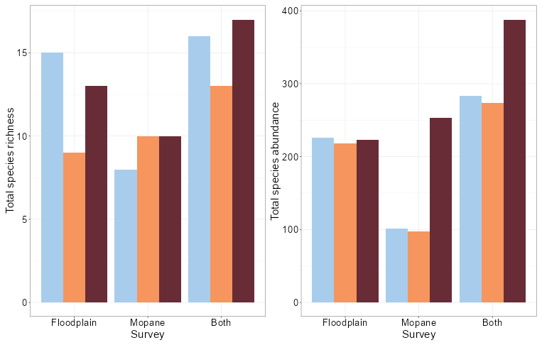
Figure 13. Maximum daily species richness and abundance of herbivores for each survey, including maximum daily cumulative species richness and abundance across both transects for 2023 (blue), 2024 (orange), and 2025 (purple)
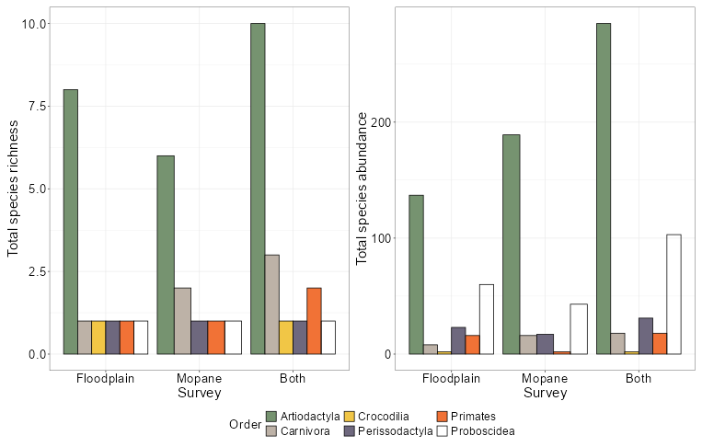
Figure 14. Maximum daily species richness and abundance of vertebrates at each herbivore survey, divided into taxonomic orders, including maximum daily cumulative species richness and abundance across both transects. Floodplain and mopane transects were surveyed three times

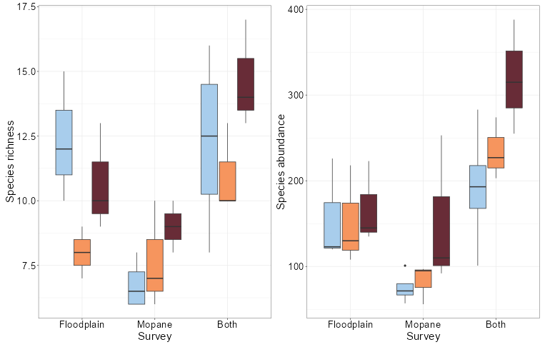
Figure 15. Box plots of daily species richness and abundance for each transect, including daily cumulative species richness and abundance across both surveys in 2023 (blue), 2024 (orange), and 2025 (purple).
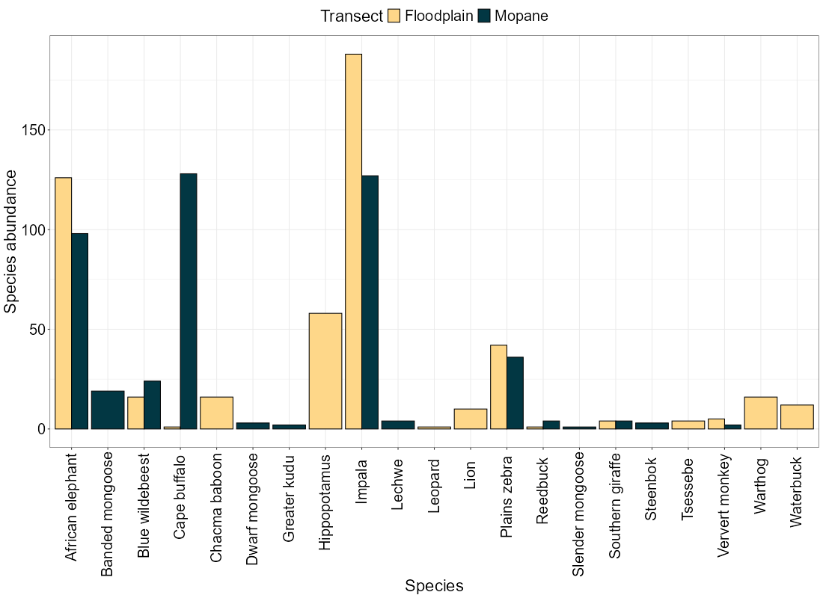
Figure 16. Total species abundances of mammals from herbivore surveys, divided into floodplain and mopane transects.
Cumulative species richness stabilised as sample effort increased (Fig 17), indicating that sampling effort was adequate to capture species diversity in both mopane and floodplain habitats in NG18.
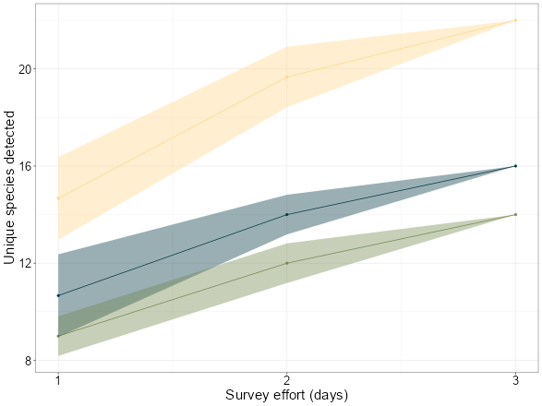
Figure 17. Species accumulation curve for herbivores surveys overall (yellow), in floodplain transects (blue), and in mopane transects (green)
We estimated the density of detected mammal species based on transect distance sampling (Table 1). This method is not suited to several species, particularly those that are wide ranging, or rare species that are only sporadically detected. To satisfy model assumptions, we excluded species that we observed only once (leopards and slender mongoose). Other wide ranging or rare species are included in the analysis but are marked with a “*”.
Estimated species populations have been generally steady since 2023, though estimates of giraffes, zebra, kudu, and tsessebe were all lower this year than in 2024 (Fig. 18), probably because of the dry conditions of the previous two years but also reflecting the stochasticity of detection for non-sedentary species . Elephant populations increased to upwards of 20 000 this year, four times the estimate in 2024.

Table 1. Estimated mammal densities, with SE, and estimated abundance during 2024 and 2025 within the Khwai Private Reserve (2000 km2), using distance sampling. Sporadically detected species (e.g. those that are rarely observed, wide-ranging, and/or have a clumped distribution) that are likely to give vastly inaccurate estimates using this method are identified with an “*”
Common name | Scientific name | 2023 density (SE) | 2024 density (SE) | 2025 Density (SE) | 2023 Abundance | 2024 Abundance | 2025 Abundance
Carnivores
Black backed jackal* | Lupulella mesomelas | 0.68 (55233.06) | 0.13 (11905.28) | - | 1189.45 | 222.53
Dwarf mongoose | Helogale parvula | - | - | 1.71 (1.46) | - | - | 2993.77
Banded mongoose* | Mungos mungo | 1.5 (150206.1) | 14.9 (11.37) | 12.9 (9.86) | 2628.61 | 26073.98 | 22568.52
Lion | Panthera leo | - | - | 5.88 (7.48) | - | - | 10283.73
Crocodile | Crocodylus niloticus | - | - | 0.21 (0.3) | - | - | 363.55
Herbivores
Impala | Aepyceros molampus | 23.53 (0.92) | 25.22 (14.19) | 45.33 (16.15) | 41175.13 | 44129.75 | 79331.89
Blue wildebeest | Connochaetus taurinus | 0.32 (0.33) | 0.11 (9147.35) | 1 (1.26) | 559.29 | 191.58 | 1758.09
Tsessebe | Damaliscus lunatus | 0.5 (0.05) | 0.56 (0.63) | 0.27 (0.34) | 876 | 974.17 | 468.83
Southern giraffe | Giraffa camelopardalis | - | 1.15 (0.42) | 0.46 (0.23) | - | 2008.78 | 807.83
Hippopotamus* | Hippopotamus amphibius | - | - | 3.82 (4.78) | - | - | 6680.72
Sable antelope* | Hippotragus niger | 0.21 (4320.31) | 0.44 (5843.16) | - | 375.16 | 764.77 | -
Roan antelope | Hippotragus equinus | - | 0.04 (0.16) | - | - | 68.23 | -
Waterbuck | Kobus ellipsiprymnus | - | - | 0.8 (1.01) | - | - | 1406.47
Lechwe | Kobus leche | - | - | 0.2 (0.15) | - | - | 351.62
Warthog | Phacochoerus africanus | 0.73 (0.21) | 0.94 (0.82) | 0.7 (0.91) | 1275.88 | 1652.83 | 1222.04
Steenbok | Raphicerus campestris | - | 0.38 (0.41) | 0.48 (0.42) | - | 667.19 | 847.06
Reedbuck | Redunca arundinum | - | - | 0.13 (0.1) | - | - | 234.41
Cape buffalo* | Syncerus caffer_caffer | 1.05 (0.27) | 0.27 (0.14) | 11.36 (8.37) | 1844.51 | 468.25 | 19883.63
Greater kudu | Tragelaphus strepsiceros | 0.6 (0.11) | 0.78 (0.9) | 0.13 (0.1) | 1045.02 | 1369.44 | 234.41
Plains zebra | Equus burchelli | 6.16 (0.43) | 9.69 (11.29) | 5.02 (1.87) | 10788.7 | 16962.83 | 8790.43
African elephant* | Loxodonta africana | 2.14 (0.67) | 3.58 (0.67) | 13.33 (2.5) | 3741.03 | 6268.44 | 23330.8
Primates
Vervet monkey | Cercopithecus aethiops | 7.76 (1.89) | 1.91 (1.79) | 1.77 (1.3) | 13588.49 | 3338.9 | 3101.72
Chacma baboon | Papio ursinus | 13.12 (37.6) | 3.73 (95965.66) | 7.62 (9.65) | 22960.65 | 6531.86 | 13338.12

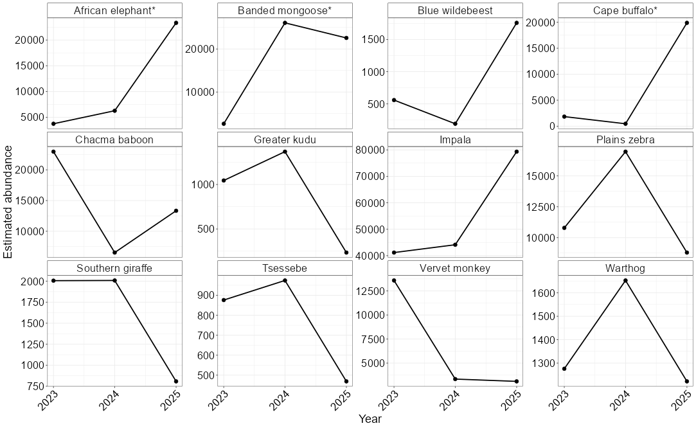
Figure 18. Estimated abundance of selected species in 2023, 2024, and 2025. This mostly demonstrates the stochasticity of detection.
In 2019, Round River Conservation Studies and the Okavango River Institute surveyed NG18, focussing on six key species with the most sightings. We also surveyed these species in 2023-2025. Since 2019, we have observed a decline in kudu and giraffe populations, an increase in impala and elephant populations, and a stable zebra population (Table 2, Fig. A1)

Table 2. Estimated densities of five species reported in most recent dry season survey of NG18 (RR (2019); Orrick et al. 2021), the PLuS Alliance survey of July 2023 (PLuS All. 2023), the PLuS Alliance survey of July 2024 (PluS All., 2024), and the PLuS Alliance survey of July 2025 (PLuS All., 2025). Estimated density and SE are reported. Distance sampling was used to generate density estimates.
Common name | Scientific name | Survey | Density | Density SE
Impala | Aepyceros melampus | RR (2019) | 10.32 | 2.05
 |  | PLuS All. (2023) | 23.53 | 0.92
 |  | PLuS All. (2024) | 25.22 | 14.19
 |  | PLuS All. (2025) | 45.33 | 16.15
Plains zebra | Equus quagga | RR (2019) | 7.23 | 1.01
 |  | PLuS All. (2023) | 6.16 | 0.43
 |  | PLuS All. (2024) | 9.69 | 11.29
 |  | PLuS All. (2025) | 5.02 | 1.87
Southern giraffe | Giraffa giraffa | RR (2019) | 1.19 | 0.26
 |  | PLuS All. (2023) | 1.15 | 0.18
 |  | PLuS All. (2024) | 1.15 | 0.42
 |  | PLuS All. (2025) | 0.46 | 0.23
African Savannah elephant | Loxodonta africana | RR (2019) | 3.22 | 1.4
 |  | PLuS All. (2023) | 2.14 | 0.67
 |  | PLuS All. (2024) | 3.58 | 0.67
 |  | PLuS All. (2025) | 13.33 | 2.5
Greater kudu | Tragelaphus strepsiceros | RR (2019) | 2.15 | 0.32
 |  | PLuS All. (2023) | 0.6 | 0.11
 |  | PLuS All. (2024) | 0.78 | 0.9
 |  | PLuS All. (2025) | 0.13 | 0.1

Freshwater invertebrate sampling
xx

Water quality sampling

Camera traps
We did not perform any formal analysis on the camera trap images due to the short deployment time and limited number of cameras, but we detected four mammal species. We recommend the establishment of long-term monitoring of key water crossings that could allow for a more comprehensive analysis. This would involve the deployment of a greater number of cameras at additional sites, and the additional data could be processed efficiently with AI pipelines.

Table 3. Camera deployments in NG18 and mammals detected
Camera location | Date deployed | Date removed | Nights active | Deployment duration (h) | Mammal species detected | List Mammals detected
Tuludi | 01 JUL 2025 10:11AM | 04 JUL 2025 16:18 | 3 | 78h 7m | 3 | Leopard, lion, spotted hyaena
Tau camp | 04 JUL 2024 22:05 | 05 JUL 2024 06:39 | 1 | 8h 34m | 2 | Spotted hyaena, stripe-sided jackal
Total | - | - | 4 | 86h 41m | 5 | Leopard, lion, spotted hyaena, stripe-sided jackal

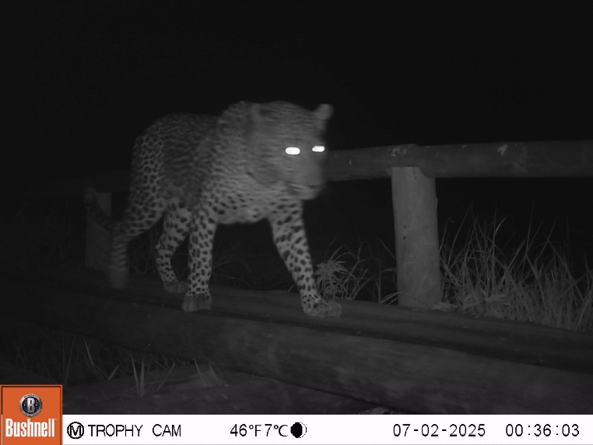  a) | 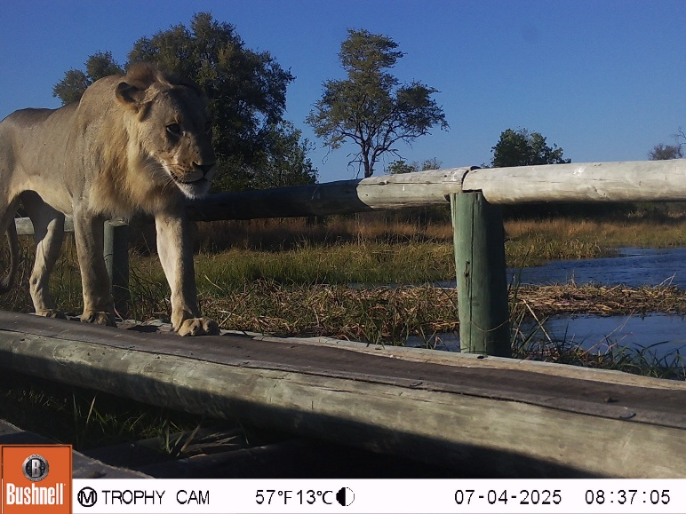  b)
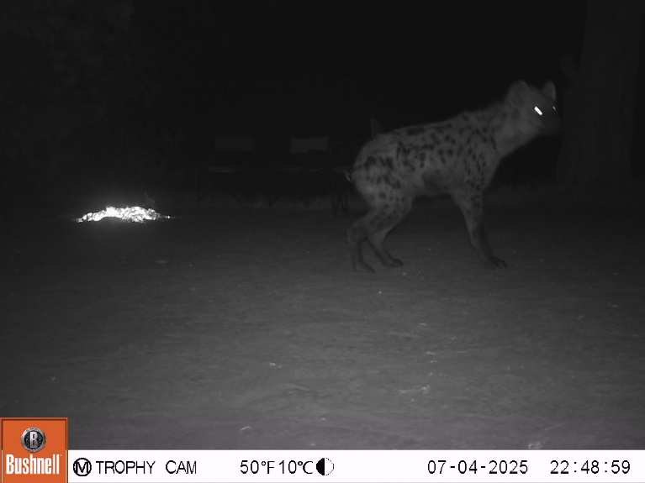  c) | 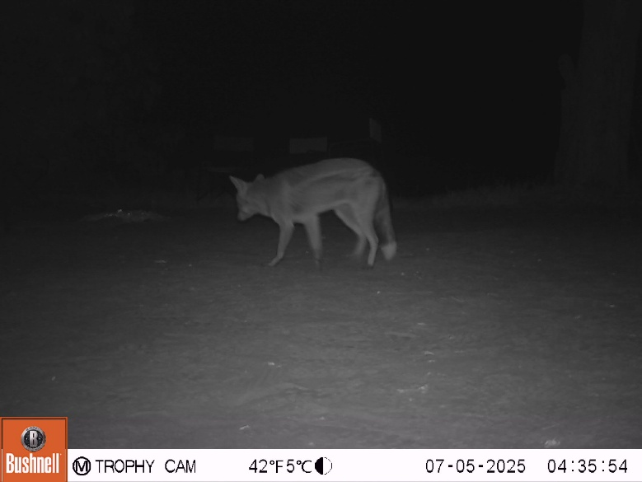  d)
Figure 19. Camera-trap images from NG18; (a) Leopard, (b) Lion, (c) Spotted hyena, and (d) side-striped jackal

Bibliography
Burger, K., 2020. The relationship between flooding parameters and grazing herbivores in the south-western Okavango Delta (PhD Thesis). University of the Witwatersrand, Johannesburg.
Francis, R., Bino, G., Inman, V., Brandis, K., Kingsford, R.T., 2021. The Okavango Delta’s waterbirds – Trends and threatening processes. Global Ecology and Conservation 30, e01763. https://doi.org/10.1016/j.gecco.2021.e01763
Gumbricht, T., McCarthy, T.S., Merry, C.L., 2001. The topography of the Okavango Delta, Botswana, and its tectonic and sedimentological implications. South African Journal of Geology 104, 243–264. https://doi.org/10.2113/1040243
Inman, V.L., Lyons, M.B., 2020. Automated Inundation Mapping Over Large Areas Using Landsat Data and Google Earth Engine. Remote Sensing 12, 1348. https://doi.org/10.3390/rs12081348
Lourenco, M., Woodborne, S., Fitchett, J.M., 2023. Drought history and vegetation response in the Angolan Highlands. Theor Appl Climatol 151, 115–131. https://doi.org/10.1007/s00704-022-04281-4
Marshall, L., Miller, D., Clark-Wolf, T.J., Thomas, L., Laake, J., Rexstad, E., 2024. Distance: Distance Sampling Detection Function and Abundance Estimation.
McCarthy, T.S.*, Cooper, G.R.J. **, Tyson, P.D. ***&Ellery W.N. ****, 2000. Seasonal flooding in the Okavango Delta, Botswana - recent history and future prospects. South African Journal of Science 96, 25–33. https://doi.org/10.10520/AJA00382353_7717
McCarthy, T.S., Humphries, M.S., Mahomed, I., Le Roux, P., Verhagen, B.Th., 2012. Island forming processes in the Okavango Delta, Botswana. Geomorphology 179, 249–257. https://doi.org/10.1016/j.geomorph.2012.08.016
Milzow, C., Kgotlhang, L., Bauer-Gottwein, P., Meier, P., Kinzelbach, W., 2009. Regional review: the hydrology of the Okavango Delta, Botswana—processes, data and modelling. Hydrogeol J 17, 1297–1328. https://doi.org/10.1007/s10040-009-0436-0
Moliner Cachazo, L., Makati, K., Chadwick, M.A., Catford, J.A., Price, B.W., Mackay, A.W., Guiry, M.D., Murray-Hudson, M., Murray-Hudson, F., 2023. A review of the freshwater diversity in the Okavango Delta and Lake Ngami (Botswana): taxonomic composition, ecology, comparison with similar systems and conservation status. Aquat Sci 85, 115. https://doi.org/10.1007/s00027-023-01008-z
Muthoni, F.K., Odongo, V.O., Ochieng, J., Mugalavai, E.M., Mourice, S.K., Hoesche-Zeledon, I., Mwila, M., Bekunda, M., 2019. Long-term spatial-temporal trends and variability of rainfall over Eastern and Southern Africa. Theor Appl Climatol 137, 1869–1882. https://doi.org/10.1007/s00704-018-2712-1
QGIS.org, 2024. QGIS Geographic Information System.
R Core Team, 2024. R: A Language and Environment for Statistical Computing. R Foundation for Statistical Computing, Vienna, Austria.
Ramberg, L., Hancock, P., Lindholm, M., Meyer, T., Ringrose, S., Sliva, J., Van As, J., Vander Post, C., 2006. Species diversity of the Okavango Delta, Botswana. Aquat. Sci. 68, 310–337. https://doi.org/10.1007/s00027-006-0857-y
Ramsar, 2021. Okavango Delta System (Ramsar Information Sheet).
Shen, Z., Yong, B., Gourley, J.J., Qi, W., Lu, D., Liu, J., Ren, L., Hong, Y., Zhang, J., 2020. Recent global performance of the Climate Hazards group Infrared Precipitation (CHIRP) with Stations (CHIRPS). Journal of Hydrology 591, 125284. https://doi.org/10.1016/j.jhydrol.2020.125284
Sullivan, B.L., Aycrigg, J.L., Barry, J.H., Bonney, R.E., Bruns, N., Cooper, C.B., Damoulas, T., Dhondt, A.A., Dietterich, T., Farnsworth, A., Fink, D., Fitzpatrick, J.W., Fredericks, T., Gerbracht, J., Gomes, C., Hochachka, W.M., Iliff, M.J., Lagoze, C., La Sorte, F.A., Merrifield, M., Morris, W., Phillips, T.B., Reynolds, M., Rodewald, A.D., Rosenberg, K.V., Trautmann, N.M., Wiggins, A., Winkler, D.W., Wong, W.-K., Wood, C.L., Yu, J., Kelling, S., 2014. The eBird enterprise: An integrated approach to development and application of citizen science. Biological Conservation 169, 31–40. https://doi.org/10.1016/j.biocon.2013.11.003
UNESCO, 2024. Okavango Delta - UNESCO World Heritage Centre [WWW Document]. URL https://whc.unesco.org/en/list/1432/ (accessed 12.2.24).

Appendix
Table A1. Bird species observed in the daily point surveys and their associated functional group
Common name | Scientific Name | Functional Group | Sites | Maximum Count
African fish eagle | Icthyophaga vocifer | Piscivore | A, B, C | 3
African grey hornbill | Lophoceros nasutus | Omnivore | A, C | 2
African jacana | Actophilornis africanus | Carnivore | A, B | 7
African palm swift | Cypsiurus parvus | Insectivore | A, B | 4
African reed warbler | Acrocephalus baeticatus | Insectivore | B | 3
African stonechat | Saxicola torquatus | Insectivore | C | 2
African swamphen | Porphyrio madagascariensis | Omnivore | A | 1
Arnots chat | Myrmecocichla arnotti | Insectivore | A, B, C | 4
Ashy flycatcher | Muscicapa caerulescens | Insectivore | B | 4
Banded martin | Neophedina cincta | Insectivore | B, C | 4
Bateleur | Terathopius ecaudatus | Carnivore | A, B, C | 2
Black crake | Zapornia flavirostra | Omnivore | A, C | 1
Black flycatcher | Melaenornis pammelaina | Insectivore | B | 2
Blacksmith lapwing | Vanellus armatus | Carnivore | A, B, C | 4
Blue waxbill | Uraeginthus angolensis | Omnivore | A | 2
Brown-snake eagle | Circaetus cinereus | Carnivore | A, B, C | 1
Brubru | Nilaus afer | Insectivore | B | 1
Buffalo weaver | Bubalornis niger | Omnivore | A, B | 3
Burchell's starling | Lamprotornis australis | Omnivore | A, B, C | 4
Cape starling | Lamprotornis nitens | Herbivore | A | 2
Cape turtle-dove | Streptopelia capicola | Omnivore | A, B, C | 12
Cape wagtail | Motacilla capensis | Insectivore | B, C | 2
Capped wheatear | Oenanthe pileata | Insectivore | B | 1
Cattle egret | Bubulcus ibis | Carnivore | A, C | 5
Chinspot batis | Batis molitor | Insectivore | B | 2
Common moorehen | Gallinula chloropus | Omnivore | A | 1
Coppery-tailed coucal | Centropus cupreicaudus | Carnivore | A, B, C | 3
Emerald-spotted wood dove | Turtur chalcospilos | Omnivore | A | 1
Finch | - |  | A | 1
Fork-tailed drongo | Dicrurus adsimilis | Insectivore | A, B, C | 7
Goliath heron | Ardea goliath | Piscivore | B | 1
Great egret | Ardea alba | Piscivore | B | 1
Great white pelican | Pelecanus onocrotalus | Piscivore | A | 17
Greater painted-snipe | Rostratula benghalensis | Omnivore | C | 2
Greater striped swallow | Cecropis cucullata | Omnivore | B, C | 4
Greenwood hoopoe | Phoeniculus purpureus | Insectivore | C | 1
Grey go-away bird | Crinifer concolor | Omnivore | A | 2
Hamerkop | Scopus umbretta | Carnivore | A, B | 1
Hooded vulture | Necrosyrtes monachus | Carnivore | A, B, C | 3
Intermediate egret | Ardea intermedia | Carnivore | B | 2
Laughing dove | Spilopelia senegalensis | Omnivore | A, B | 2
Lilac-breasted roller | Coracias caudatus | Carnivore | A, B, C | 4
Little bee-eater | Merops pusillus | Insectivore | A, B | 5
Little egret | Egretta garzetta | Carnivore | A, C | 6
Long-toed lapwing | Vanellus crassirostris | Insectivore | B, C | 5
Magpie shrike | Urolestes melanoleucus | Omnivore | A | 1
Marsh harrier | Circus ranivorus | Carnivore | A, B, C | 1
Meves's starling | Lamprotornis mevesii | Omnivore | A | 1
Meyers parrot | Poicephalus meyeri | Herbivore | A, B | 2
Mourning collared dove | Streptopelia decipiens | Herbivore | A | 2
Namaqua dove | Oena capensis | Herbivore | A | 1
Pied kingfisher | Ceryle rudis | Piscivore | A, B, C | 3
Prinia | Prinia sp. | Insectivore | A | 2
Quelea | Quelea sp. | Insectivore | A, B | 30
Rattling cisticola | Cisticola chiniana | Insectivore | B | 2
Red-billed hornbill | Tockus rufirostris | Omnivore | A | 2
Red-eyed dove | Streptopelia semitorquata | Omnivore | A | 1
Redbilled quelea | Quelea quelea | Herbivore | A | 20
Ring-necked dove | Streptopelia capicola | Omnivore | A, B, C | 5
Rufous-bellied heron | Ardeola rufiventris | Carnivore | B | 1
Saddle-billed stork | Ephippiorhynchus senegalensis | Carnivore | B | 1
Senegal coucal | Centropus senegalensis | Carnivore | A, B, C | 2
Southern black tit | Melaniparus niger | Insectivore | A | 2
Spur-winged goose | Plectropterus gambensis | Herbivore | A, B | 6
Squacco heron | Ardeola ralloides | Carnivore | A, B, C | 2
Striped kingfisher | Halcyon chelicuti | Insectivore | A | 1
Tinkling cisticola | Cisticola rufilatus | Insectivore | B | 2
Water thick-knee | Burhinus vermiculatus | Carnivore | B | 2
White-backed vulture | Gyps africanus | Carnivore | A, B, C | 4
Yellow-billed egret | Ardea brachyrhyncha | Omnivore | A, C | 2
Yellow-billed hornbill | Tockus leucomelas | Omnivore | C | 1
Yellow-billed oxpecker | Buphagus africanus | Insectivore | B | 2

Table A2. Common name, sites where observed and maximum count across all days and sites of incidentally sighted mammals and reptiles from waterbird surveys, divided into functional groups
Common name | Scientific Name | Functional group | Sites | Maximum Count
African Reed Buck | Redunca arundinum | Herbivore | A, B | 2
Elephant | Loxodonta africana | Herbivore | A, B | 1
Giraffe | Giraffa giraffa angolensis | Herbivore | C | 2
Hippo | Hippopotamus amphibius | Herbivore | B, C | 9
Impala | Aepyceros melampus | Herbivore | B | 20
Nile Crocodile | Crocodylus niloticus | Carnivore | B, C | 4
Red Lechwe | Kobus leche | Herbivore | A, B, C | 27
Water Monitor | Varanus niloticus | Carnivore | B | 1
Water buck | Kobus ellipsiprymnus | Herbivore | A, B | 4

Table A3. Species list of birds identified in NG18 on eBird
Common name | Scientific Name
African Hoopoe | Upupa africana
African Jacana | Actophilornis africanus
African Grey Hornbill | Tockus nasutus
African Hawk Eagle | Aquila spilogaster
African Fish Eagle | Haliaeetus vocifer
African Spoonbill | Platalea alba
Bateleur | Terathopius ecaudatus
Black-winged Stilt | Himantopus himantopus
Blacksmith Lapwing | Vanellus armatus
Burchell's Sandgrouse | Pterocles burchelli
Blue Waxbill | Uraeginthus angolensis
Burchell's Starling | Lamprotornis australis
Cape Turtle Dove | Streptopelia capicola
Cattle Egret | Bubulcus ibis
Cape Glossy Starling | Lamprotornis nitens
Cardinal Woodpecker | Dendropicos fuscescens
Crested Francolin | Dendroperdix sephaena
Crested Barbet | Trachyphonus vaillantii
Dark-capped Bulbul | Pycnonotus barbatus
Double-banded Sandgrouse | Pterocles bicinctus
Egyptian Goose | Alopochen aegyptiaca
Fork-tailed Drongo | Dicrurus adsimilis
Green Wood-Hoopoe | Phoeniculus purpureus
Goliath Heron | Ardea goliath
Grey Heron | Ardea cinerea
Hamerkop | Scopus umbretta
Helmeted Guineafowl | Numida meleagris
Laughing Dove | Spilopelia senegalensis
Lilac-Breasted Roller | Coracias caudatus
Little Bee-eater | Merops pusillus
Little Grebe | Tachybaptus ruficollis
Magpie Shrike | Urolestes melanoleucus
Meve's Starling | Lamprotornis mevesii
Pied Kingfisher | Ceryle rudis
Red-billed Buffalo Weaver | Bubalornis niger
Red-billed Quelea | Quelea quelea
Red-billed Spurfowl | Pternistis adspersus
Red-billed Teal | Anas erythrorhyncha
Red crested Korhaan | Lophotis ruficrista
Red-eyed Dove | Streptopelia semitorquata
Saddle-billed Stork | Ephippiorhynchus senegalensis
Slaty Egret | Egretta vinaceigula
Southern Ground Hornbill | Bucorvus leadbeateri
Southern Red-Billed Hornbill | Tockus rufirostris
Southern Yellow-Billed Hornbill | Tockus leucomelas
Spur-winged Goose | Plectropterus gambensis
Swainson Spurfowl | Pternistis swainsonii
Tropical Boubou | Laniarius aethiopicus
White-backed Vulture | Gyps africanus
Yellow-billed Oxpecker | Buphagus africanus
Yellow-billed Stork | Mycteria ibis
Wattled Crane | Grus carunculatus
White-backed Vulture | Gyps africanus
White-crested Helmetshrike | Prionops plumatus
White-crowned Lapwing | Vanellus albiceps

Table A 4. Common name, scientific name, transects where observed and maximum count across all days and transects of vertebrates from herbivore surveys, divided into orders
Common name | Scientific name | Maximum count | Transects
Artiodactyla
Blue wildebeest | Connochaetus taurinus | 14 | Mopane, Floodplain
Cape buffalo | Syncerus caffer caffer | 127 | Floodplain, Mopane
Greater kudu | Tragelaphus strepsiceros | 2 | Mopane
Hippopotamus | Hippopotamus amphibius | 25 | Floodplain
Impala | Aepyceros molampus | 40 | Mopane, Floodplain
Lechwe | Kobus leche | 2 | Mopane
Reedbuck | Redunca arundinum | 2 | Mopane, Floodplain
Southern giraffe | Giraffa camelopardalis | 3 | Mopane, Floodplain
Steenbok | Raphicerus campestris | 1 | Mopane
Tsessebe | Damaliscus lunatus | 4 | Floodplain
Warthog | Phacochoerus africanus | 5 | Floodplain
Waterbuck | Kobus ellipsiprymnus | 6 | Floodplain
Carnivora
Banded mongoose | Mungos mongo | 16 | Mopane
Dwarf mongoose | Helogale parvula | 3 | Mopane
Leopard | Panthera pardus | 1 | Floodplain
Lion | Panthera leo | 8 | Floodplain
Slender mongoose | Galerella sanguinea | 1 | Mopane
Crocodilia
Crocodile | Crocodylus niloticus | 2 | Floodplain
Perissodactyla
Plains zebra | Equus burchelli | 18 | Mopane, Floodplain
Primates
Chacma baboon | Papio ursinus | 16 | Floodplain
Ververt monkey | Cercopithecus aethiops | 5 | Floodplain, Mopane
Proboscidea
African elephant | Loxodonta africana | 31 | Mopane, Floodplain

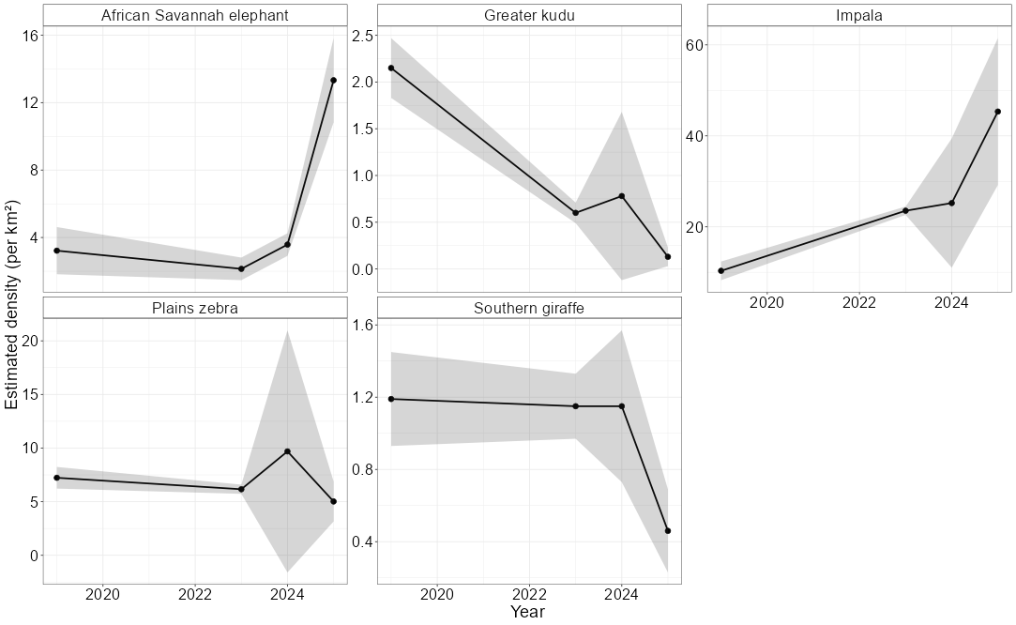
Figure A 1. Estimated densities of five species reported in most recent dry season survey of NG18 (RR (2019); Orrick et al. 2021), the PLuS Alliance survey of July 2023 (PLuS All. 2023), the PLuS Alliance survey of July 2024 (PluS All., 2024), and the PLuS Alliance survey of July 2025 (PLuS All., 2025). Estimated density and SE are reported. Distance sampling was used to generate density estimates

